Employee Management System

Mini Project - Module 2

Name: Alan P James

This project is a console-based Employee Management System developed using Python and SQLite. The system allows users to login based on their roles such as admin, manager, or employee. It provides functionalities to manage employee data, departments, and user roles. The application stores data in a database and allows users to perform operations like adding, viewing, and managing employee records efficiently.

- User Login System
- Role-Based Access (Admin, Manager, Employee)
- Add Employee
- View Employee Details
- Database Integration using SQLite
- Simple Console-Based Interface

Users Table:
- user_id (Primary Key)
- username (Unique)
- password
- role
- name

Database Schema
Managers Table:
- manager_id (Primary Key)
- manager_name
- department_id
- user_id (Foreign Key)

How to Run
1. Install Python
2. Open terminal
3. Navigate to project folder
4. Run the command: python main.py
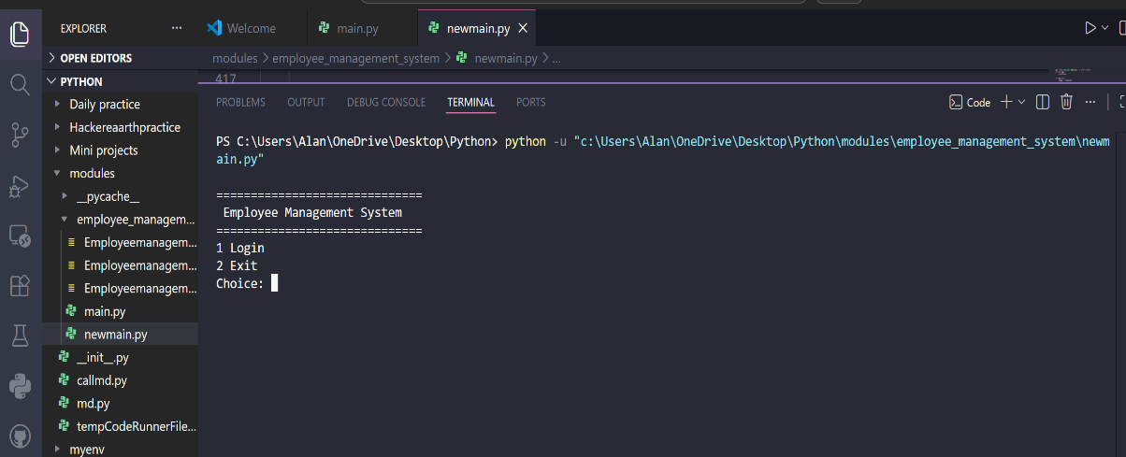
5. Follow the menu options

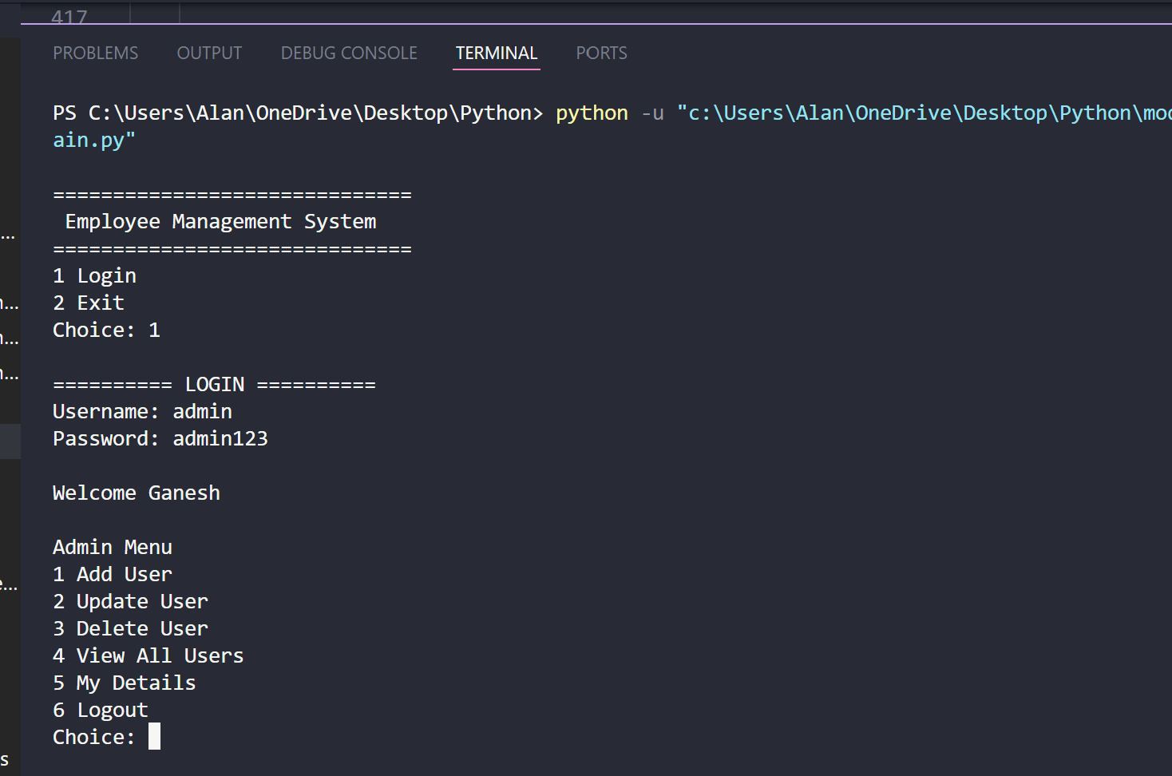
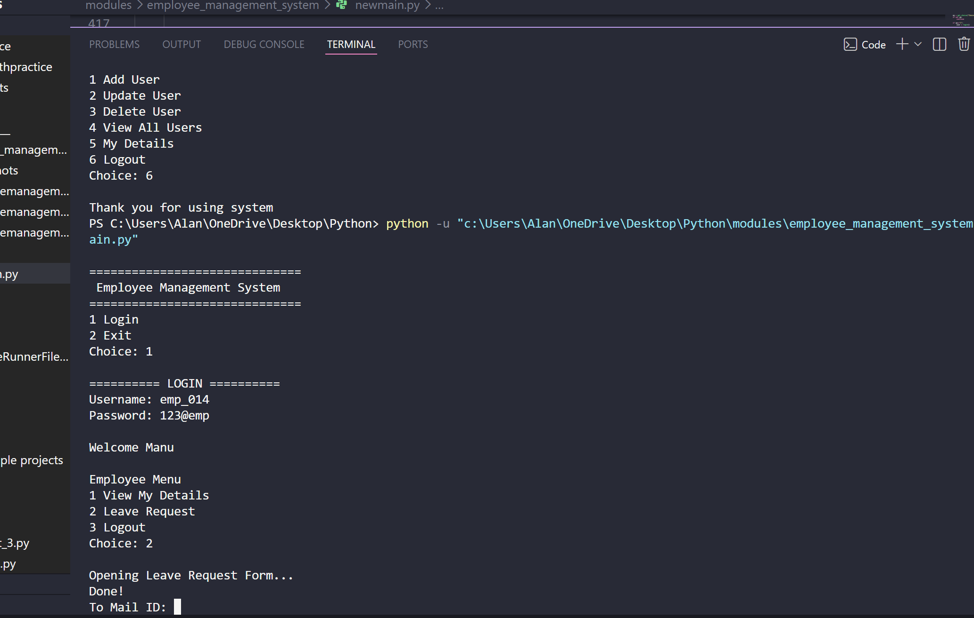

Login Instructions:

The system supports role-based login for Admin, Manager, and Employee.

Users can login using the following credentials:

Admin Login:
Username: admin
Password: admin123

Manager Login:
Example:
Username: mngr_012
Password: 123@mngr

Employee Login:
Example:
Username: emp_013
Password: 123@emp

Instructions:
1. Run the application using python main.py
2. Select Login option
3. Enter username and password
4. Based on the role, the system will redirect to respective menu (Admin / Manager / Employee)

Note: Different users have different roles, and access is restricted based on their role.

Multiple users are pre-stored in the database for testing purposes.

